Supplementary information

Gut microbiome-derived lactate promotes to anxiety-like behaviors through GPR81 receptor-mediated lipid metabolism pathway
Baixi Shan^{1,a}, Yonggui Song^{1,a}, Sufen Zengª, Jiagui Song^{b}, Qiang Zengª, Zhou Liaoª, Tingting Wangª, Chao Huangª, Dan Su ∗^{,a}

ª Laboratory Animal Science and Technology Center, College of Pharmacy, College of Science and Technology, Jiangxi University of Traditional Chinese Medicine, 1688 Meiling Road, Nanchang 330004, China
^{b}Key Laboratory of Carcinogenesis and Translational Research (Ministry of Education), and State Key Laboratory of Natural and Biomimetic Drugs, Peking University, Beijing 100191, China

¹These authors contributed equally to this work

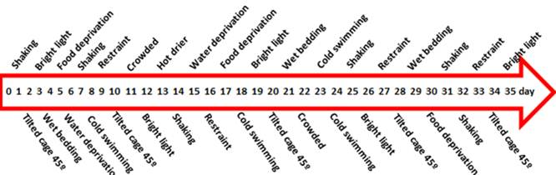

Fig. S1 Chronic unpredictable stress experimental schedule

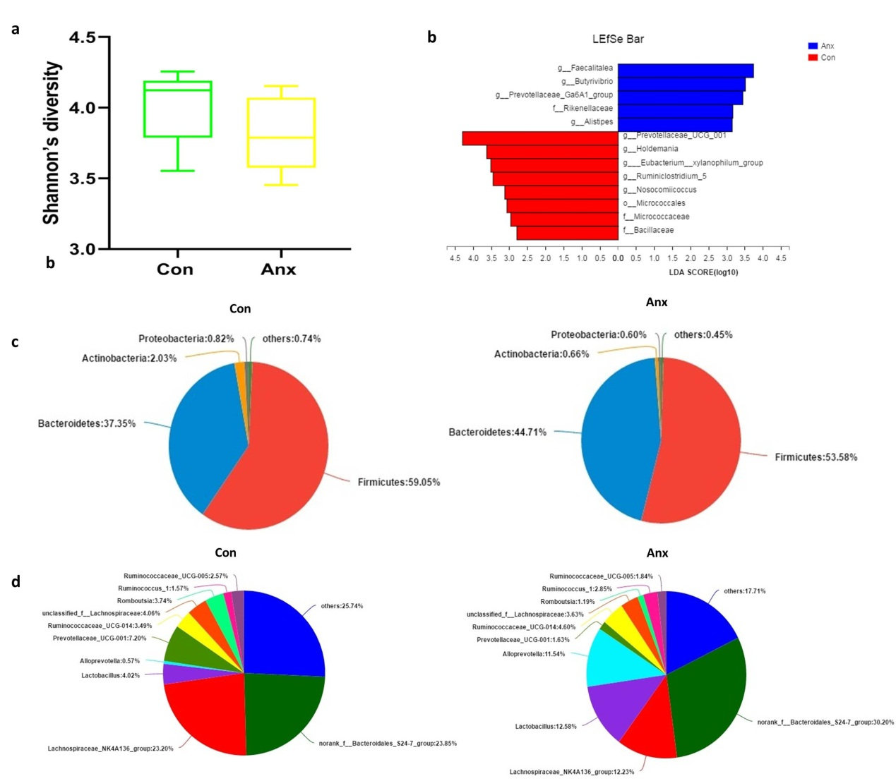
Fig. S2 Analysis of gut microbiome diversity. a α-Phylogenetic diversity analysis showed that anxiety rat were characterized by lower diversity (Shannon) indices relative to control rat. b LDA Effect Size (LEfSe) algorithm was used on genus level OTU tables to determine taxa that best characterize each biological class. c Microbial composition of each group at the phylum and class level. d Microbial composition of each group at the genus and class level.

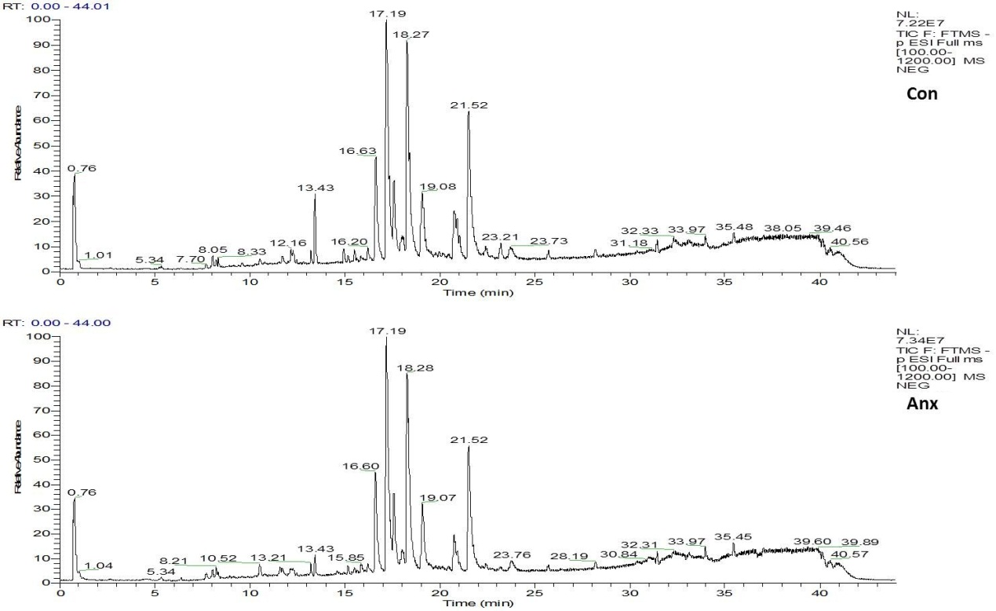
Fig. S3 Chromatogram of plasma negative ion

Fig. S4 Heat map analysis of plasma metabolite correlation.

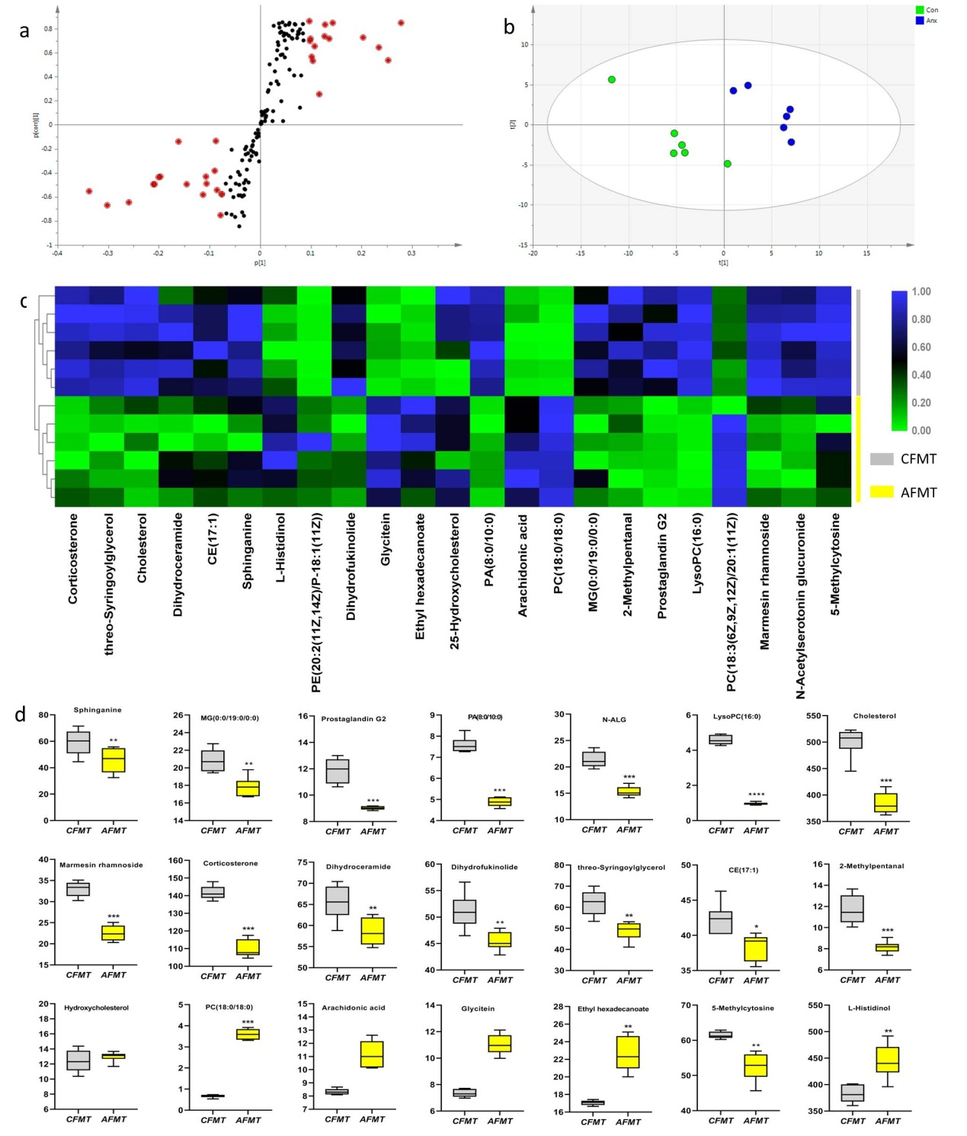
Fig. S5 Analysis of untargeting brain lipid metabolism. a S-plots of the OPLS-DA model from the anxiety and control group rats. b Partial least-square discriminant analysis (PLS-DA). The anxiety group is shown in blue, and the control group is shown in green. c Heatmap analysis of 23 significant difference metabolites from the anxiety and control group rats. d Relative intensities of individual metabolites in the anxiety and control group rats.

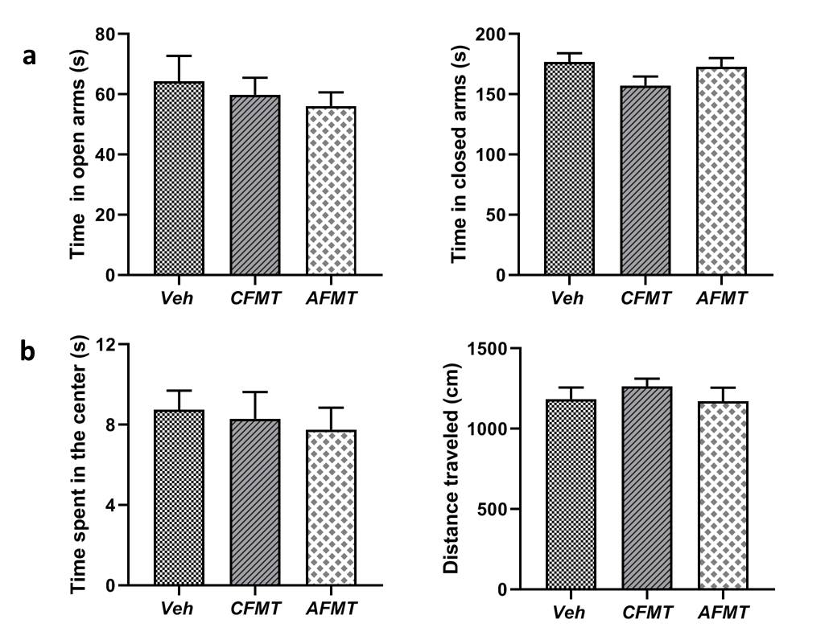
Fig. S6 Behavioral experiment. a Elevated plus maze test (EPMT). b Open-field test (OFT)

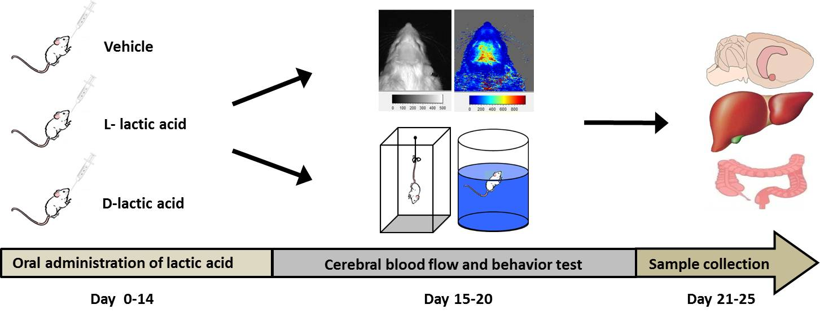

Fig. S7 Experimental design

Table.S2 The real-time PCR primer sequences

Primer Name | Primer ID | Molecular Weight (µg/µmole) | Sequence (5’to3’)
GPR81-F | 190616_001C07 | 6059.97 | CGAGGCTCTACTTCCTCTGG
GPR81-R | 190616_001D07 | 6204.09 | GCATGCTGTTCAGGTAGGTG

∗Corresponding author: Jiangxi University of Traditional Chinese Medicine, 1688 Meiling Road, Nanchang 330004, PR China. Tel/Fax: +86 791 87802135. E-mail address: sud94@aliyun.com.

